- Instructions:
- Question no 1 to 44 are of objective type and carry 2 marks each.
- Question no 45 to be written separately and carries 12 marks.

SECTION A: LOGICAL REASONING (10 x 2 = 20)

The following bar graph shows the percentage distribution of the expenditure incurred in publishing a book. Study the bar graph and answer the questions based on the graph(Question number 1 to 5 ) :

Various Expenditures (in percentage) Incurred in Publishing a Book

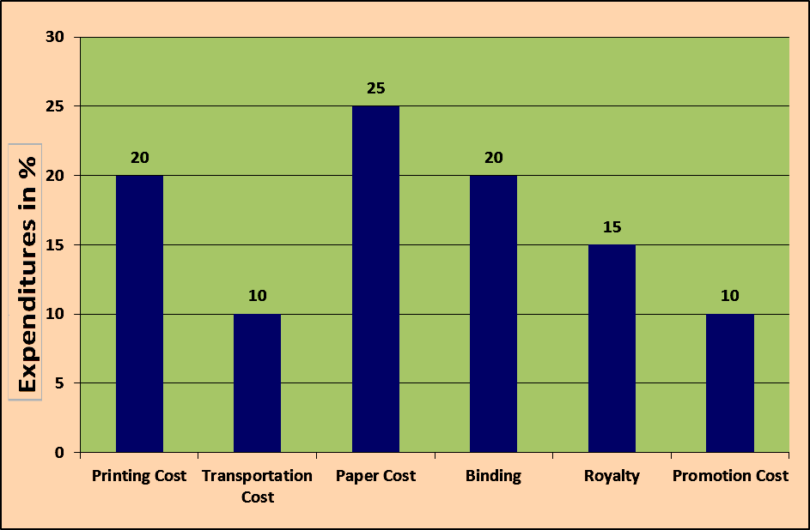

The price of the book is marked 20% above the C.P. If the marked price of the book is Rs. 180, then what is the cost of the paper used in a single copy of the book?
(A) | Rs. 36 | (B) | Rs 37.50
(C) | Rs. 42 | (D) | Rs. 44.25

The maximum of the total expenditure is done on
(A) | paper cost | (B) | printing cost
(C) | royalty | (D) | transportation

If 5500 copies are published and the transportation cost on them amounts to Rs. 82500, then what should be the selling price of the book so that the publisher can earn a profit of 25%?
(A) | Rs. 187.50 | (B) | Rs. 191.50
(C) | Rs. 175 | (D) | Rs. 180

Royalty on the book is less than the printing cost by:
(A) | 5% | (B) | 33 %
(C) | 20 % | (D) | 25 %

If for a certain quantity of books, the publisher has to pay Rs. 30,600 as printing cost, then what will be the amount of royalty to be paid for these books?
(A) | Rs. 19,450 | (B) | Rs. 21,200
(C) | Rs. 22,950 | (D) | Rs. 26,150

Yard is to inch as quart is to
(A) | gallon | (B) | ounce
(C) | milk | (D) | liquid

Look carefully at the sequence of symbols to find the pattern. Select correct pattern.
INCLUDEPICTURE "http://www.indiabix.com/_files/images/logical-reasoning/5-88-q-1.png" \* MERGEFORMATINET INCLUDEPICTURE "http://www.indiabix.com/_files/images/logical-reasoning/5-88-q-1.png" \* MERGEFORMATINET
(A) | 1 | (B) | 2
(C) | 3 | (D) | 4

Oat cereal has more fiber than corn cereal but less fiber than bran cereal.
Corn cereal has more fiber than rice cereal but less fiber than wheat cereal.
Of the three kinds of cereal, rice cereal has the least amount of fiber.
If the first two statements are true, the third statement is

(A) | True | (B) | False
(C) | Uncertain | (D) | None of all

Look carefully for the pattern, and then choose which pair of numbers comes next.
6 10 14 18 22 26 30
(A) | 34 38 | (B) | 33 37
(C) | 38 42 | (D) | 36 33

Which word does NOT belong with the others?
(A) | book | (B) | index
(C) | glossary | (D) | chapter

SECTION B: MATHEMATICS (12 x 2 = 24)

The equations of the sides of a triangle and , then the coordinates of the circumcentre are
(A) | (2,1) | (B) | (1,2)
(C) | (2,-2) | (D) | (1,-2)

If A= 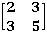 then is
(A) | 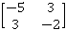 | (B) | 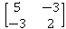
(C) | 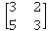 | (D) | 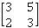

Which of the following is greatest?
(A) |  | (B)
(C) |  | (D) | 0.17

Two boys start from the same place walking at the rate of 5 kmph and 5.5 kmph respectively in the same direction. What time will they take to be 8.5 km apart?
(A) | 17 hr | (B) | 14 hr
(C) | 12 hr | (D) | 19 hr

The equation of circle drawn on the diagonal of the rectangle as its diameters whose sides are is,
(A) | x² + y² – 3x – 2y + 21 = 0 | (B) | x² + y² – 3x + 2y + 21 = 0
(C) | x² + y² + 3x – 2y + 21 = 0 | (D) | x² + y² – 3x – 2y – 21 = 0

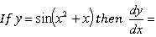
(A) |  | (B)
(C) |  | (D)

The foci of the hyperbola are
(A) |  | (B)
(C) |  | (D)

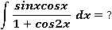
(A) |  | (B) | 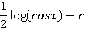
(C) | 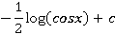 | (D) | 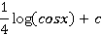

A room has three sockets. A person selects 3 bulbs at random from a collection of 15 bulbs of which 5 are defective and puts them into the sockets, the probability that there will be light from all the three bulbs is,
(A) |  | (B)
(C) |  | (D)

In how many ways can the letters of the word 'LEADER' be arranged?
(A) | 72 | (B) | 144
(C) | 360 | (D) | 720

A kite is flying at an inclination of 60⁰ with the horizontal. If the length of the thread is 120 m then the height of the kite is
(A) | m | (B) | 60 m
(C) | m | (D) | 120 m

If = i – 2 k , = - 3i + 5 k , = 2i – 7 k and = x + y then x and y are respectively
(A) | 3 , 11 | (B) | 11 , 3
(C) | 11 , 4 | (D) | 11 , 5

SECTION C: SCIENCE (12 x 2 = 24)

Two blocks of ice when pressed together join to form one block because
(A) | of cold produced during pressing | (B) | of heat produced during pressing
(C) | melting point of ice decreases with increase in pressure | (D) | melting point of ice decreases with decrease in pressure

Which of the following only produce virtual images? (Assuming s > 0)
(A) | converging lenses and concave mirrors | (B) | diverging lenses and concave mirrors
(C) | converging lenses and convex mirrors | (D) | diverging lenses and convex mirrors

A body of mass 10 kg and velocity 10m/s collides with a stationary body of mass 5 kg. After collision, both bodies stick to each other. The common velocity would be
(A) | 3/20 m/s | (B) | 20/3 m/s
(C) | 10/3 m/s | (D) | 3/10 m/s

Ultrasonics are used in SONAR with greater advantage because ultrasonics,
(A) | have low frequency | (B) | have short wavelength
(C) | are electromagnetic waves | (D) | can be easily produced

The surface tension of a liquid is 70 dyne / cm. In MKS system its value is
(A) | 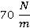 | (B) | 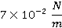
(C) | 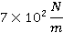 | (D) | 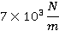

A ball is dropped on the ground from a height of 1m. The coefficient of restitution is 0.6.The height to which the ball will rebound is
(A) | 0.6m | (B) | 0.4m
(C) | 0.36m | (D) | 0.16m

Which statement is wrong about chloroform:
(A) | Chloroform is used as anaesthetic | (B) | Chloroform has distorted shape
(C) | Chloroform is used as a solvent | (D) | chloroform has sp²-hybridised carbon atom

27 g of Al (at mass=27)will react with oxygen equal to
(A) | 24 g | (B) | 8 g
(C) | 40 g | (D) | 10 g

Sodium chloride is an ionic compound whereas hydrogen chloride is a gas because
(A) | Sodium is reactive | (B) | Covalent bond is weaker than ionic bond
(C) | Hydrogen chloride is a gas | (D) | Covalent bond is stronger than ionic bond

Which of the order for ionization energy is correct
(A) | Be>B>C>N>O | (B) | B<Be<C<O<N
(C) | B <Be<C<N<O | (D) | B<Be<N<C<O

I mole of a compound contain 1 mole of C and 2 moles of O. The molecular weight is,
(A) | 3 | (B) | 12
(C) | 32 | (D) | 44

Which of the nitrates on strong heating leaves the metal as the residue?
(A) | AgNO3 | (B) | Pb(NO3)2
(C) | Cu(NO3)2 | (D) | Al(NO3)3

SECTION D: ENGLISH
Q. Fill in the blanks with most suitable word(s) given below. (10 x 2 = 20)

Right now I __________ in front of a computer, trying to do an exercise about tenses.
(A) | sit | (B) | am sit
(C) | sitting | (D) | am sitting

Last night at seven o'clock Radha __________ dinner with her family.
(A) | had | (B) | has had
(C) | was having | (D) | was had

I'm sorry I missed your call. I __________ a shower and I simply didn't hear the phone ring.
(A) | had | (B) | was having
(C) | had had | (D) | had been having

Look! The sun ------ over the hills.
(A) | rises | (B) | is rise
(C) | is rising | (D) | will rise

All my friends are glass-____-full people. I guess that's why they always manage to cheer me up when I get depressed.
(A) | nearly | (B) | barely
(C) | half | (D) | under

______you like one more drink?
(A) | Might | (B) | Would
(C) | Could | (D) | Should

You can’t understand it, ____you?
(A) | can | (B) | do
(C) | could | (D) | don’t

I am so tired _____ I cannot go on.
(A) | also | (B) | and
(C) | even | (D) | that

_____! What are you doing there?
(A) | Hush | (B) | Hello
(C) | Hurrah | (D) | Alas

We travelled ____train.
(A) | by | (B) | through
(C) | in | (D) | from

LETTER WRITING (12 X 1 = 12)

Write a complaint letter to the Police Commissioner of Traffic, about inadequate parking facility in your area.

======== ALL THE BEST =========

